- Bluebook Page127 May 2019 variant one examination:

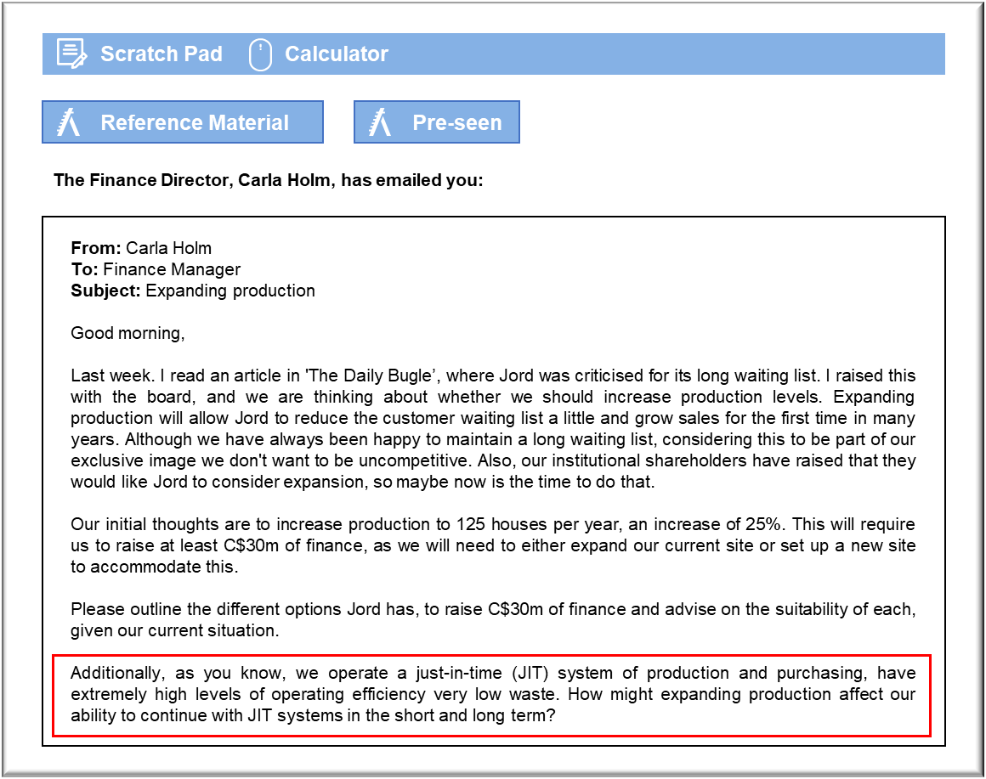MANAGEMENT CASE STUDY MAY 2019 EXAM ANSWERS

Variant1 Task1
These answers have been provided by CIMA for information purposes only. The answers created are indicative of a response that could be given by a good candidate. They are not to be considered exhaustive, and other appropriate relevant responses would receive credit.

CIMA will not accept challenges to these answers on the basis of academic judgement.

The following approaches are worth considering:
a) Existing cash resources. We currently have significant levels of cash. It might
be worth considering investing some of that in our project. It should, however,
be borne in mind that this cash is an asset that has already been funded by
Jord, through debt, equity or a combination of the two. Existing cash balances
are not, therefore, an inexpensive source of funds. It would, however, have the
advantage of eliminating the costs associated with raising finance. There could
be problems if we divert funds that are required for some other purpose. We
could, for example, find it necessary to raise additional cash in the future and
so we will only be delaying those costs.
b) Debt. The business has no existing debt or gearing, but is consistently
profitable and also has a number of assets (property, plant, inventory and trade
receivable) which could be provided as security to a bank. Therefore, we should
be able to raise a significant sum of money in this way. The cheapest debt is
usually provided by securing the debt against assets, so we should look at that
option first, and then a cash flow loan based on our historical profit/cash
generation which will be slightly more expensive. In terms of disadvantages, we
will need to pay these loans back out of cash flow over several years, and
interest will be charged annually, although interest can be offset against the
organisations tax liability.
c) Equity. The final option is by raising equity from new investors. This will affect
the shareholders more than the company as it will dilute the percentage of the
business they currently have, but the new shareholder may require a certain
level of control of management decisions which could be undesirable. They
might also want to sell the business in the future to realise their investment. A
cheaper and potentially more straightforward way of raising equity would be a
rights issue for existing shareholders. This carries no implications for the
company itself, shareholders would retain their relative share, and is almost the
These answers have been provided by CIMA for information purposes only. The answers
created are indicative of a response that could be given by a good candidate. They are
not to be considered exhaustive, and other appropriate relevant responses would
receive credit.
CIMA will not accept challenges to these answers on the basis of academic judgement.
same as the cancellation of the dividend noted in b) above, as cancelling a
dividend or putting cash in amounts to the same thing. For example, if we are
due to pay a dividend of $100 but need $100 investment from the same
shareholder who would receive the dividend, then cancelling the dividend
amounts to the same thing.

Just-in-time and expansion plans
A just-in-time (JIT) system depends upon seamless working within an organisation
and between an organisation and its suppliers.
In the short term, expanding by 25% will impact on our ability to operate the JIT
systems in the way we do now. Efficiencies will be lost whilst getting used to operating
at the new higher production levels.
The extent to which our approach is disrupted depends on the effectiveness of our
management team in expanding in an ordered and effective manner. It also depends
on the choice we make between expanding production via an extension of the current
site or expanding to a new distant location.
Expansion of the existing site seems most likely to minimise the impact on JIT
working. Although it will take time to train new staff members to get up to speed and
become fully efficient in their ways of working, ordering systems and linkages between
different stages of production are likely to remain similar. In that scenario we might
predict that, although there are likely to be short-term issues with preserving just-in?time working, they are unlikely to persist long-term.
If, however, we expand by taking on a new site that is geographically some distance
from the current operations, JIT working is likely to be more fundamentally impacted.
The efficiency impact is likely to be higher, however, if the distant site is chosen. There
will be an impact arising from the logistics of how the two sites work together.
Depending on which elements of production are located at the distant site, there could
be issues with transporting raw materials or work in progress between the sites, issues
with communication between the two sites and by physically splitting the workforce
inefficiencies arising from any members of staff who need to operate at both sites – for
example, potentially our quality control team. This may lead us to choose to expand
the current site as a more efficient option if there aren’t any other issues that may
make that a sub-optimal choice when we investigate the details of this expansion.
Whichever site we choose there will be an impact on suppliers, and we will have to talk
to them about how quickly they can meet higher levels of demand. Some suppliers may
find it easy to quickly flex their output to meet our new levels of demand, but for others
it may take time to meet the new levels of materials required.
Also, irrespective of the choice of site, if new machines are needed it will take time to
order those, implement them and train staff in their use. All these implications will
impact our just in time approach regardless of whether we expand the current site or
develop a site further away.
We will, however, seek to ensure efficiency is improved as soon as possible whichever
way we manage the expansion, and that JIT working resumes as soon as possible. Will
still strive to minimise waste and work fluidly as we always have. Therefore, I would
hope the impact would be short-term, and that over a longer time scale we can start to
return to the outstanding levels of efficiency we operate at now.

